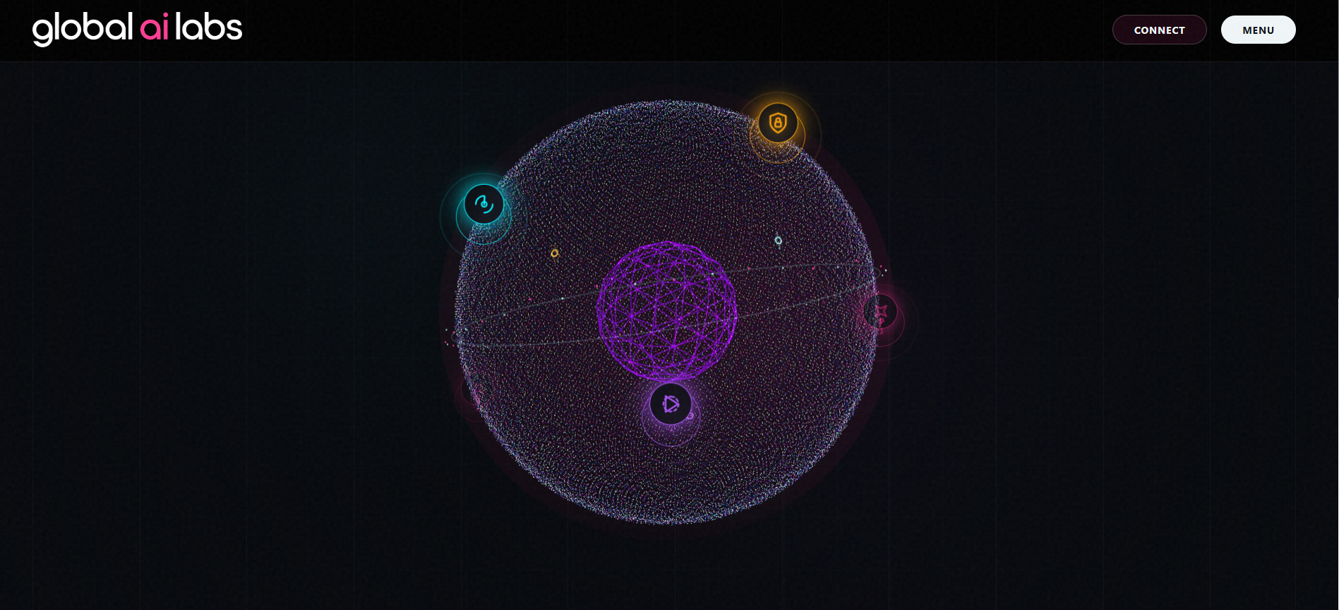

Update: One-stop AI powered content ecosystem has to be added
Update : World Map on the globe/sphere has to be added
Update : Background Music to be added

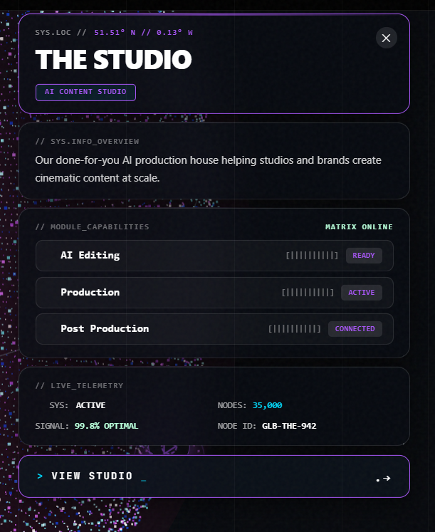
Language is fine
Update : Replace the pointers in the module capabilities from the below picture
Remove : Sys overview Tab
Update : Coming soon Live to be written in the LIVE TELEMETRY


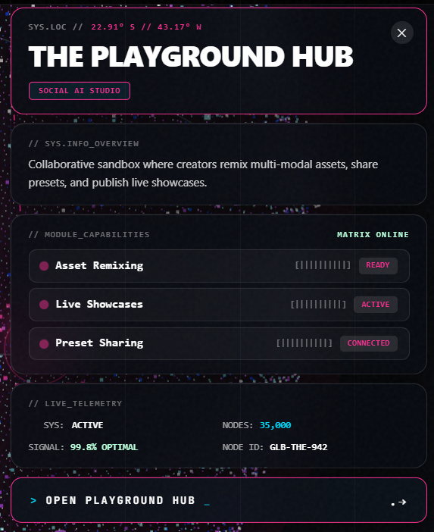
Language is fine
Update : Replace the pointers in the module capabilities from the below picture
Remove : Sys overview Tab
Update : Coming soon Live to be written in the LIVE TELEMETRY
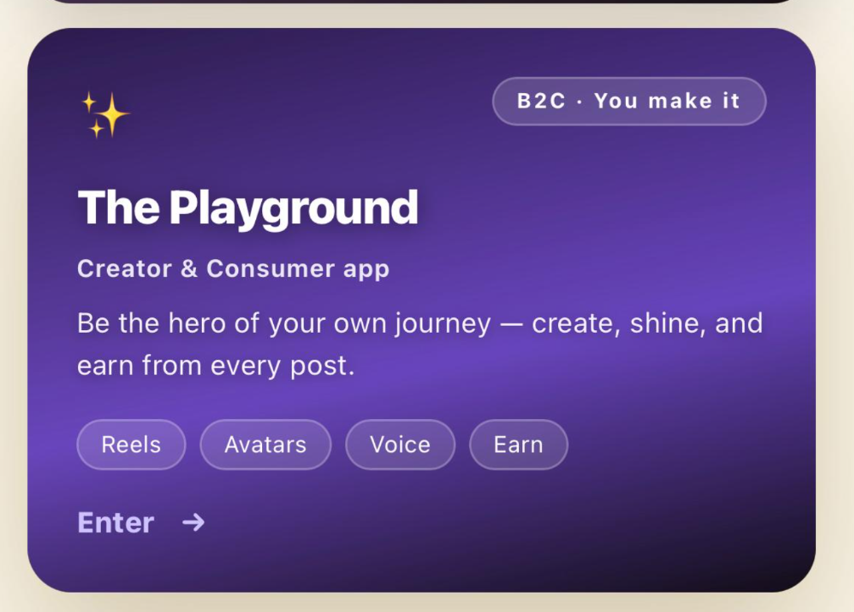

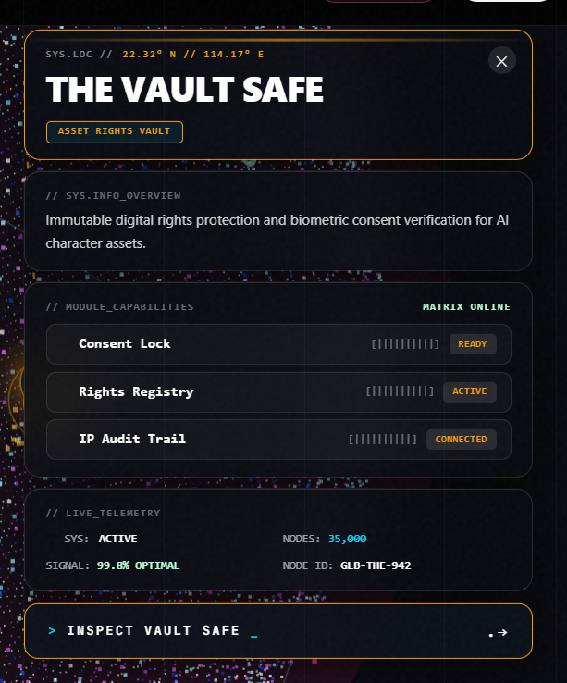
Language is fine
Update : Replace the pointers in the module capabilities from the below picture
Update : Correct the name to “THE VAULT”
Remove : Sys overview Tab
Update : Coming soon Live to be written in the LIVE TELEMETRY

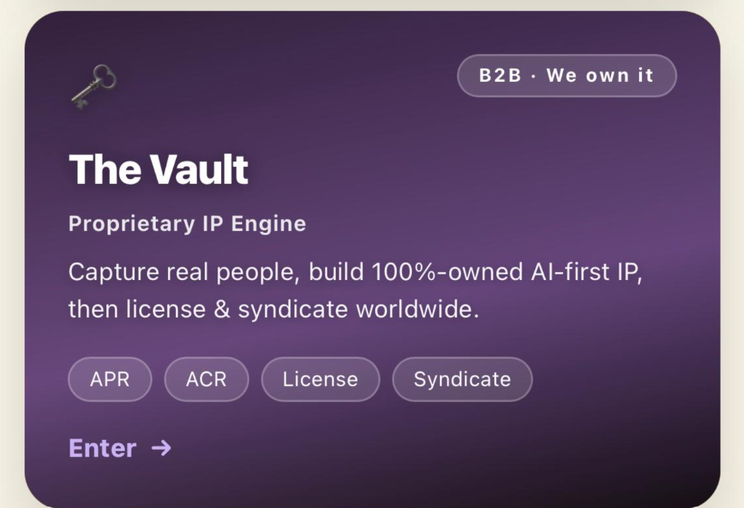

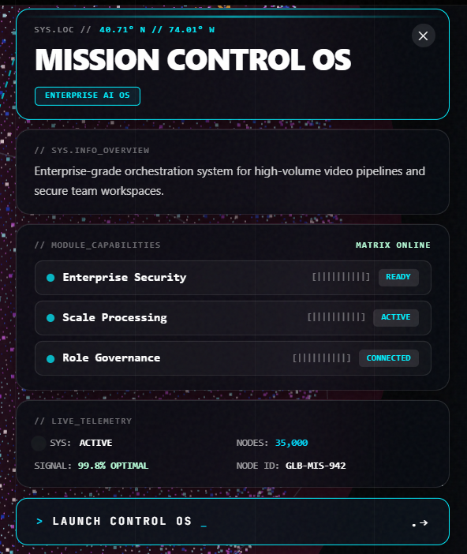

Language is fine
Update : Replace the pointers in the module capabilities from the below picture
Update : Correct the name to “THE MISSION CONTROL”
Remove : Sys overview Tab
Update : Coming soon Live to be written in the LIVE TELEMETRY

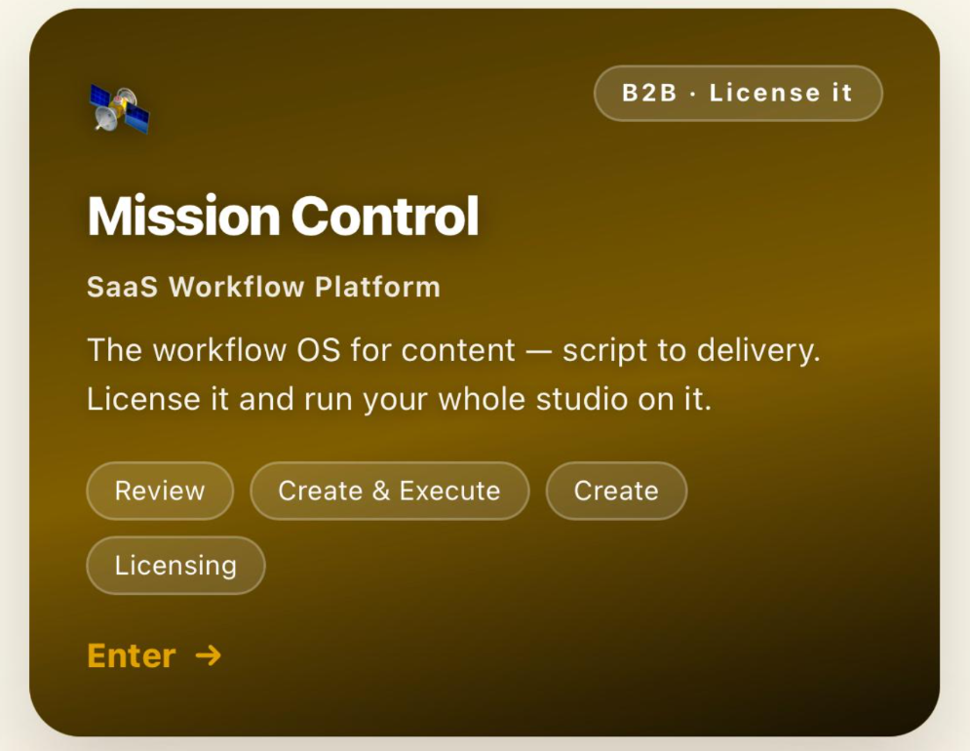
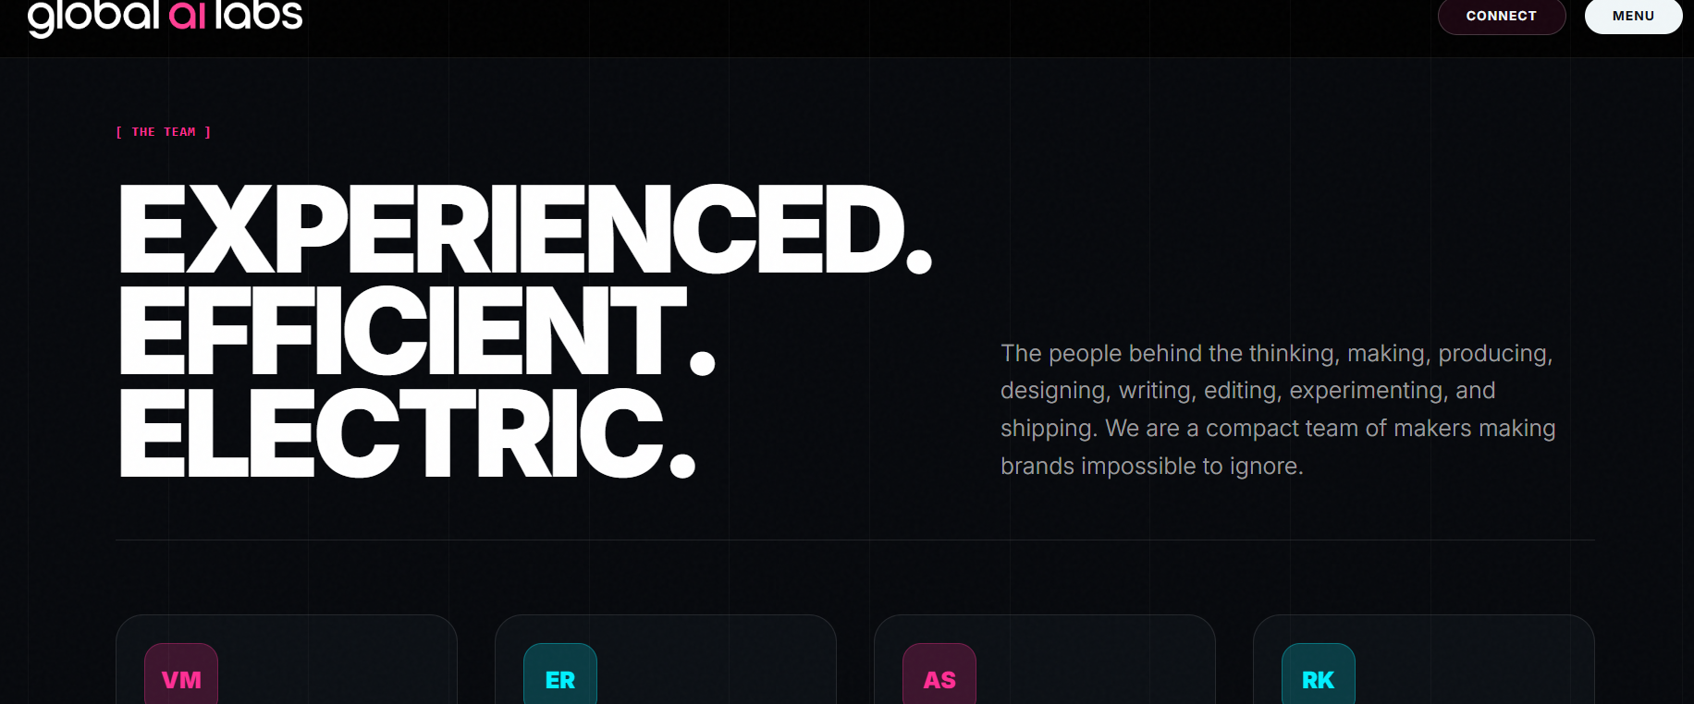

Update : add the founder’s name and designation only

Kartick Nishandar : Co-Founder & CEO
Arjun Singgh Baran : Co-Founder & COO
Vikrant Nishandar : Co-founder & CPO

